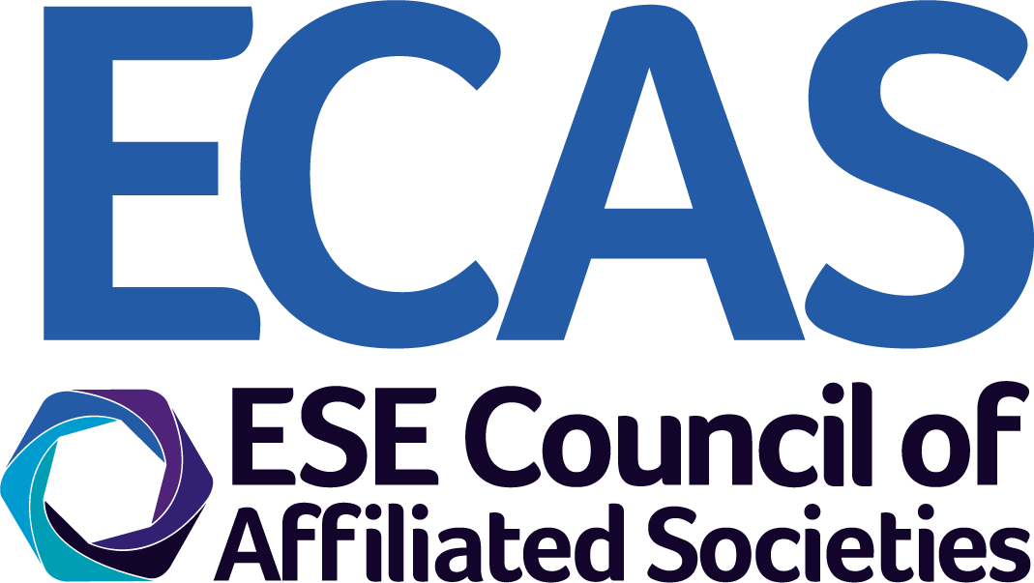


Nomination for the European Hormone Medal - 2022

The European Hormone Medal, a medal of excellence for a prestigious scientist or clinician working with hormones will be awarded at the annual European Congress of Endocrinology, where the winner will be asked to give one of the main lectures.

Members of ECAS and the ESE Science Committee are invited to submit nominations using this form and it should be returned, together with the specified documents, to the ESE Office by email to ECAS@euro-endo.org. Closing date: 28 February 2021.

1 | Name of nominee:
2 | Email address of nominee:
3 | Nominating national affiliated Society name:
4 | List 5 papers of interest that were published in international journals within the last 6 years.
5 | Please attach a letter of support which includes the merits of the nominee and the reasoning for the nomination.
6 | Please attach the CV and complete bibliography of the nominee.
Name of proposer 1 |  |  |  | Name of proposer 2
Signature of proposer 1 |  |  |  | Signature of proposer 2
Date |  |  |  | Date
Please note:
- The European Hormone Medal is awarded to an international scientist who has made significant contributions to the field of basic or clinical endocrinology. The Medal consists of a medal, certificate and a financial reward.

- The Medal will be presented at ECE 2022, 21-24 May 2022, in Milan, Italy and the nominee must be available to attend the congress to present one of the main lectures.

- Nominations for the Medal will be solicited from members of the ESE Council of Affiliated Societies (ECAS) and from the ESE Science Committee.

- Past Presidents of ESE are not eligible for four years after their term of office ends; previous recipients of the Geoffrey Harris and EJE Prizes are not be eligible for 3 years after their prize was awarded.

- The nomination form and application documents, consisting of a letter of support, CV, list of publications and merits of the candidate, should be sent by email to the ESE Office (ECAS@euro-endo.org) by the deadline stated. Self-nominations will be accepted if supported by two ESE members. Please note this form must be signed by two proposers.

- The Chair of the jury will usually be the Chair of the ESE Science Committee. The jury is composed of the Chair, the ESE President and all of the official ECAS representatives from the societies represented within ECAS. The jury is formed each year and each jury member will have one vote (ie, one vote per Society). The Chair of the jury will decide on the final list of candidates to be put forward for vote.

