Biographical sketch

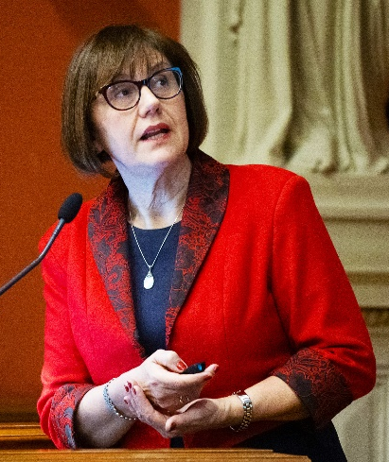
Márta Korbonits, Professor of Endocrinology and Metabolism at Barts and the London School of Medicine and Dentistry, Queen Mary University of London, working on the hormonal regulation of the metabolism and on endocrine tumorigenesis, especially the genetic origin of pituitary adenomas and other endocrine tumour syndromes.
She is Deputy Editor of Endocrine-Related Cancer and Director of the HARP Clinical Doctoral Training Programme and President of the Society for Endocrinology.

