ESE Young Endocrinologists and Scientists (EYES) Clinical and Research Observership Programmes (C.O.P and R.O.P).

QMUL – Centre for Endocrinology

The Centre for Endocrinology
The Centre for Endocrinology at Barts and the London School of Medicine and Dentistry, Queen Mary University of London is a highly translational centre, and we work embedding clinical and research collaborations. Our research topics span both paediatric and adult disease, and throughout the years we have built an international patient referral base, providing access to unique patients and families.
Our Discovery Science and Experimental Medicine successes include achieving major advances in understanding the nature and causes of Familial Pituitary Adenoma and identifying six novel genes causing Familial Glucocorticoid Deficiency, thereby providing new insights into the cellular processes regulating steroidogenesis. Adrenal and pituitary development, mitochondrial and stem cell physiology, and intracellular trafficking are complementary ongoing research interests within the Centre for Endocrinology, as is the study of novel genes underlying the timing of puberty, adrenal cancer, phaeochromocytomas and paragangliomas and rare bone diseases.
The translational aspects of our work are both inspired and supported by our clinical and basic research collaboration, which continues to serve us well in attracting high-quality clinical and non-clinical PhD students and more senior investigators to this truly international centre of excellence.
Our endocrinology clinical service is based at St Bartholomew's Hospital and offers treatment and care for many rare endocrine conditions, and we manage rare and complex diseases. The St Bartholomew’s team is one of the largest in the UK and consists of a team of multi-disciplinary specialists in endocrinology, radiology, surgery, oncology and pathology.
We have access to gold-standard diagnostic tests that are not widely available across the UK. We are one of the few endocrine centres in the country that has a dedicated day unit, where endocrine investigations are performed by our experienced nurses. We also have a dedicated inpatient ward where we look after our most complex cases.

Biographical sketches

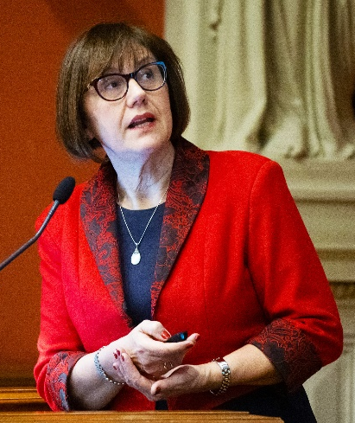
C.O.P. Mentor: Professor Márta Korbonits
Márta Korbonits, Professor of Endocrinology and Metabolism at Barts and the London School of Medicine and Dentistry, Queen Mary University of London. She is working on the hormonal regulation of the metabolism and on endocrine tumorigenesis, especially the genetic origin of pituitary adenomas and other endocrine tumour syndromes. She works on both the clinical characterisation as well as molecular aspects of pituitary diseases and leads a large international consortium to study the genetic background of endocrine tumours. She is Head of the Centre for Endocrinology at QMUL, Deputy Editor of Endocrine-Related Cancer, Director of the HARP Clinical Doctoral Training Programme, and President of the Society for Endocrinology.

Contact: m.korbonits@qmul.ac.uk

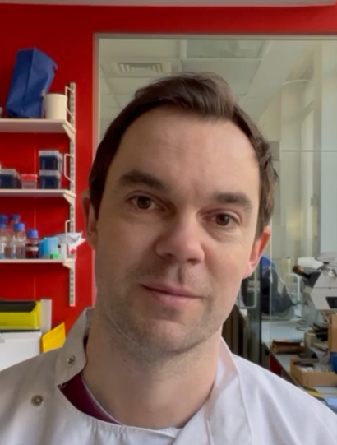
C.O.P. Early Career Investigator
James Pittaway is an Academic Clinical Lecturer working between the Centre for Endocrinology at Barts and The London School of Medicine and Dentistry and the clinical wards and outpatient clinics at St Bartholomew’s Hospital. He has recently completed a PhD looking at a possible biomarker in adrenocortical carcinoma, working the lab of Professor Leonardo Guasti. Going forward they are going to be working on establishing a possible CAR-T therapy for ACC. In his clinical role, he is a registrar on the wards and in outpatient clinics and can provide access to hands on clinical experiences in the specialist endocrine department at St Bartholomew’s Hospital.

Contact: j.pittaway@qmul.ac.uk

R.O.P. Mentor: Professor Lou Metherell
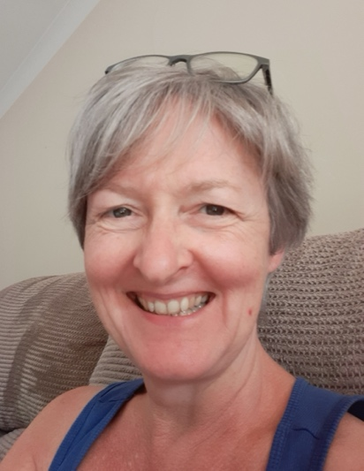
Lou Metherell, Professor of Endocrine Genetics, at Barts and the London School of Medicine and Dentistry, Queen Mary University of London. Prof Metherell studies the genetic landscape of primary adrenal insufficiency. Her main interest is in isolated glucocorticoid deficiency, where her group has established that diseases of ACTH-resistance are genetically heterogeneous, involving mutations in a diverse range of genes that promote adrenocortical development and glucocorticoid production. More recently her team have recognised syndromes involving adrenal insufficiency as one phenotype alongside cardiac, skin and neurological manifestations. This has lead to 3D models of skin to understand the ichthyosis seen in sphingosine-1-phosphate lyase deficiency, a multi-organ pathology also involving adrenal insufficiency, steroid resistant nephrosis and neurological deficits. Alongside this, iPSC work in cardiomyocytes is undertaken to study genes with cardiac involvement. She is Head of the Centre for Endocrinology at QMUL.

Contact: l.a.metherell@qmul.ac.uk

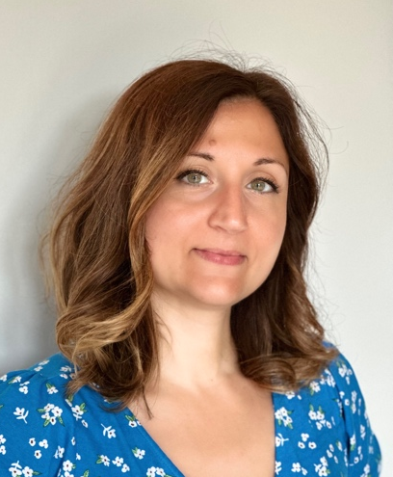
R.O.P. Early Career Investigator: Federica Begalli
Federica Begalli, Lecturer in Endocrinology, at Barts and the London School of Medicine and Dentistry, Queen Mary University of London. Federica’s main research interest is to unveil the molecular mechanisms behind tumour development and progression and use her findings in clinical applications. Her research focuses on Non-Functioning Pituitary Neuroendocrine Tumours, where she is developing novel biomarkers as well as therapeutic strategies. She works closely with clinicians and pharmaceutical companies to achieve these goals. Federica is also Education Lead for the Centre for Endocrinology and member of the Society for Endocrinology, the European Society of Endocrinology, and the European Neuroendocrine Association.

Contact: f.begalli@qmul.ac.uk

